April Taylor
ECPI University
Professor Liska
June 27, 2026
Anime Dataset Exploratory Data Analysis and Preprocessing Report
This report shows an exporatory data analysis and data preprocessing performed on the MyAnimeList anime dataset. The goal was to understand the dataset’s structure, find meaningful patterns, identify data quality issues and lastly, prepare the dataset for machine learning modeling. This analysis will focus on key numerical and categorical features that are relevant to anime popularity, audience engagement and production characteristics.

Univariate Analysis
This section examined the distribution, central tendency and variability of all the primary numerical features. These features included Score, Members, Favorites, Episodes, Ranked and Released_Year.
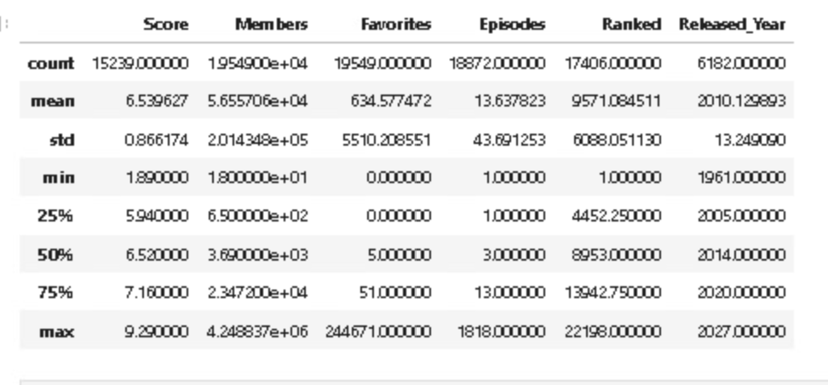

Some key observations include the Score column normally being distributed around 6.5 with a moderate spread, Members and Favorites are right-skewed heavily, Episodes showing a long tail due to long-running series, Ranked increasing with lower popularity and Released_Year ranging from 1961 to 2023 ultimately showing a wide historical span.

Histograms
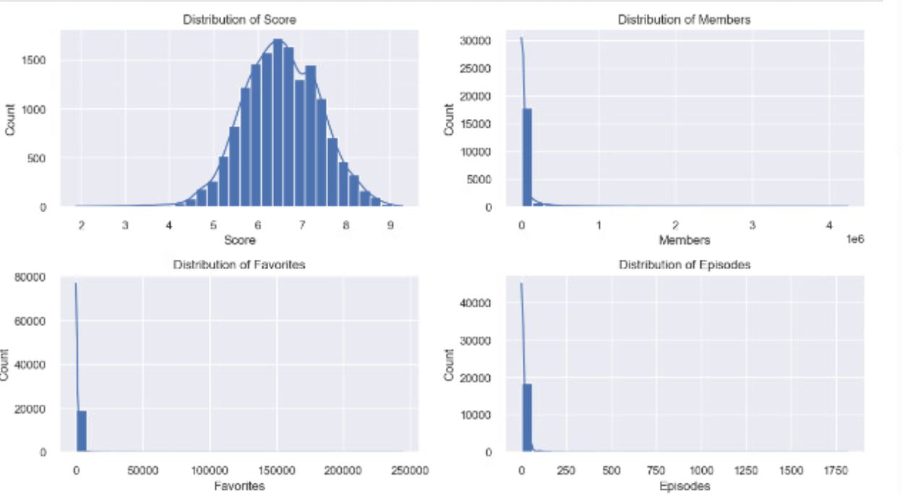
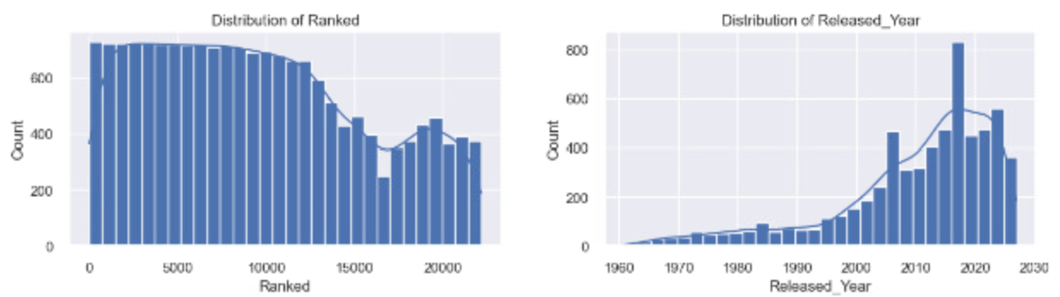

The histograms showed Members and Favorites have very extreme skewness. Episodes have numerous single-episode entries like movies or specials. Lastly, Score was centered which suggests consistent rating behavior across users.

BoxPlots
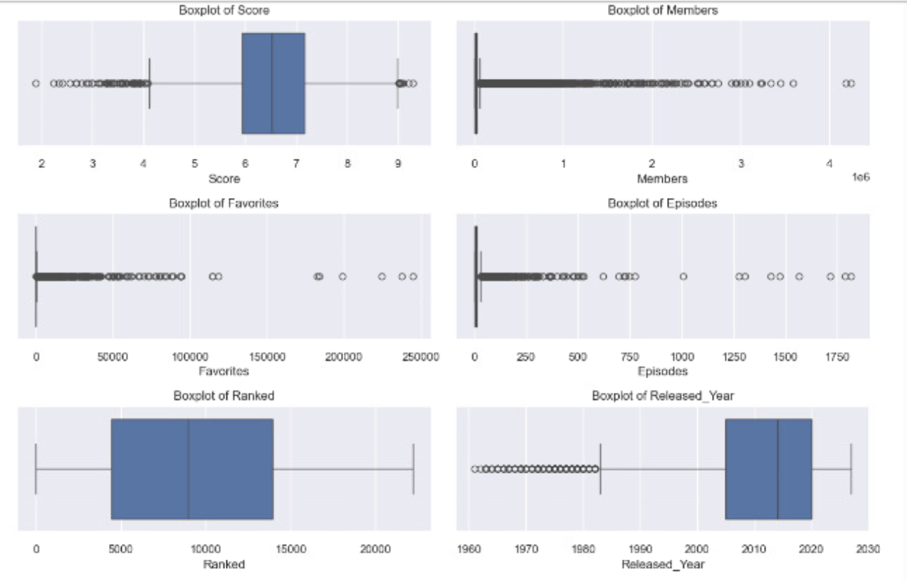

The Boxplots show Members and Favorites contain numerous significant outliers and this could be due in part to blockbuster titles for example. Episodes have extreme outliers and this could be due to long running series like One Piece or Detective Conan-not listed in this dataset.

Bivariate & Multivariate Analysis
Correlation Heatmap
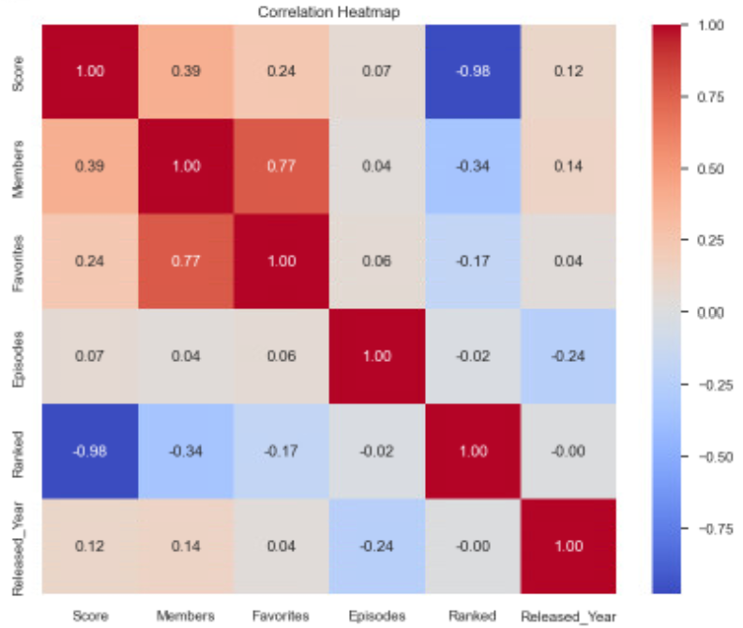
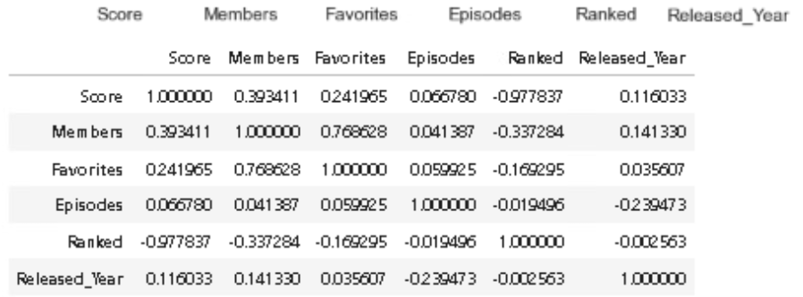

The correlation heatmap shows Members and Favorites have a strong positive correlation meaning as showed get popular, they also get more favorites. Scores and Favorites have a moderate correlation as this could be due to high rated shows being favorited more. Episodes have a weak correlation with Score suggesting that length does not really influence ratings very strongly.

Pair Plots
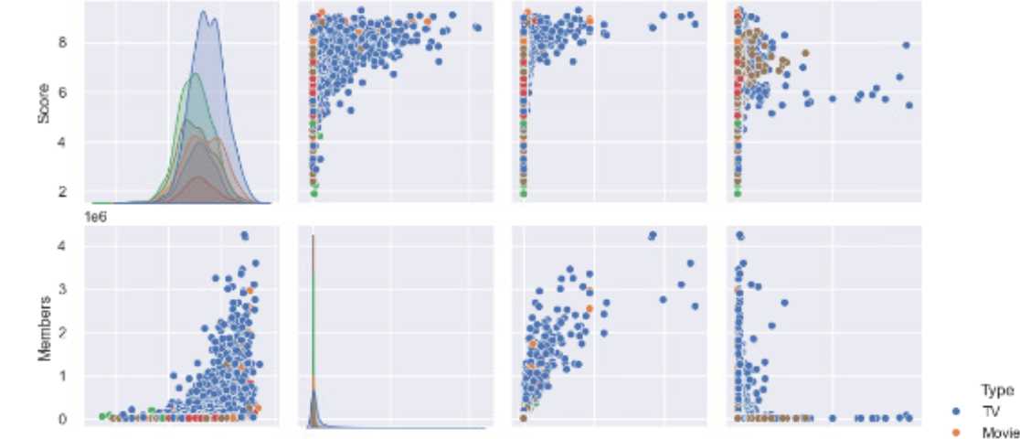
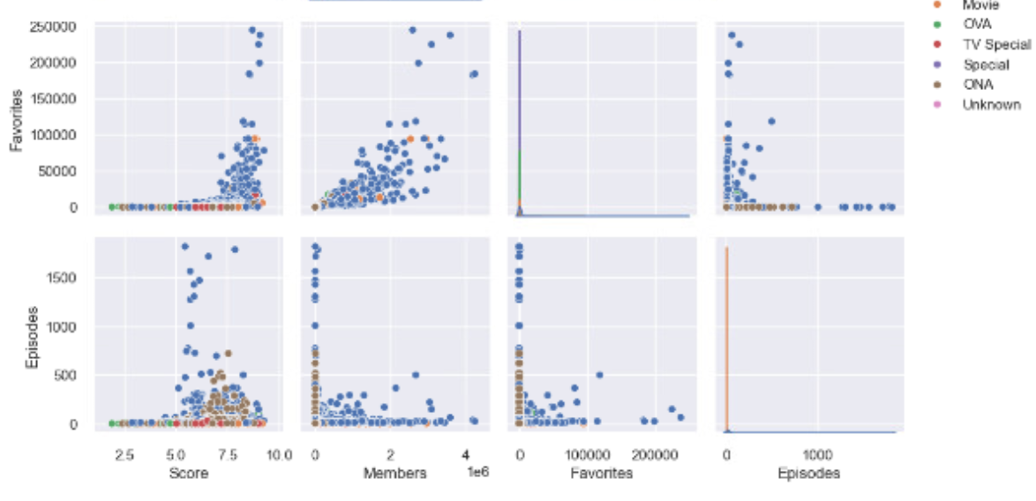

The Pair plots show separations clearly between Type categories like TV, Movies and OVA in Members and Favorites. Also, Movies tend to have fewer episodes but higher scores more often. Lastly, TV series show a wide variance in Members potentially due to long-running franchises.

Missing Data Heatmap
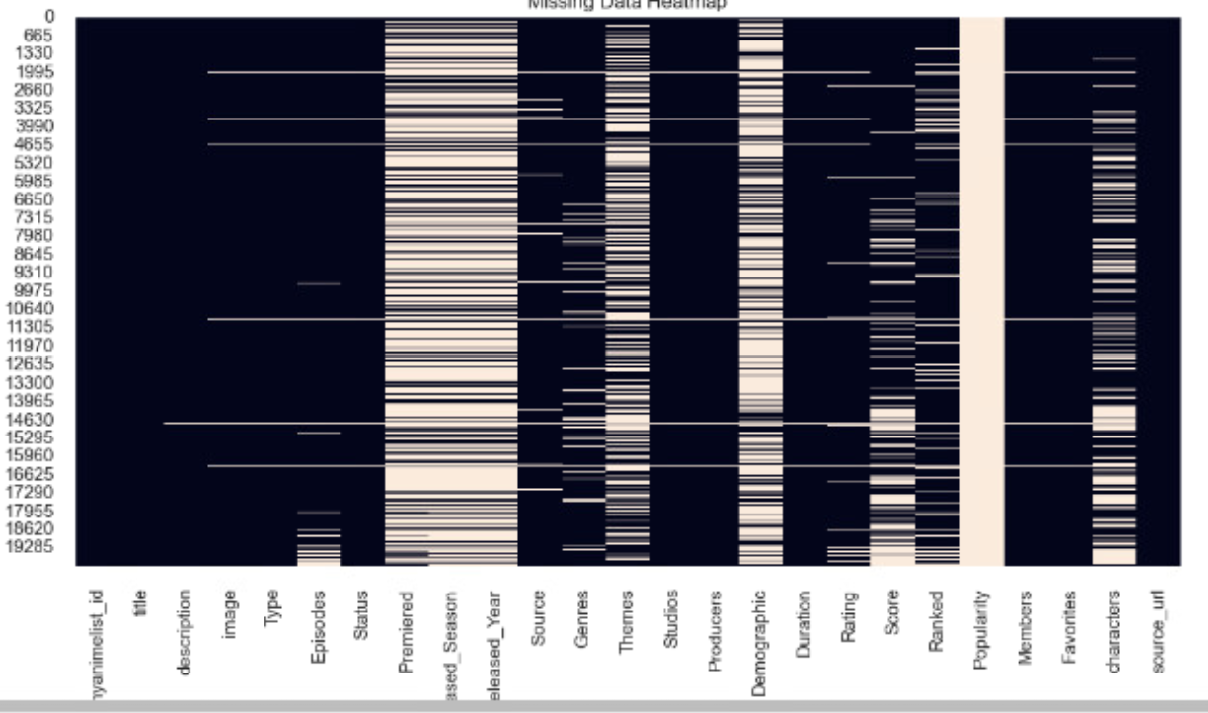
Based on this heatmap, Released_Year, Premiered, Genres and Themes have a considerable amount of missing values whereas numerical features used for the modeling have a more manageable amount of missing values.

Data Preprocessing
This part will show all outputs in which transformations were applied to prepare the dataset for machine learning. The numerical columns that had missing values were imputed with median which works well with skewed data while the categorical columns had mode imputed to help in preserving the most common category. Converting non-numeric columns, as many in this dataset were stored as text, included conversions to float, were stripped and converted or converted using coerce. One-hot encoding was used to allow the neural networks to learn from the categorial distinctions without necessarily imposing on the ordinal relationships. Feature scaling was done using StandardScaler to prevent any features from dominating, ensuring equal contributions. Lastly, PCA was done to retain a 95% variance, helping to reduce overall noise and improve efficiency.
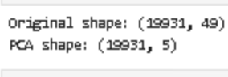
Final Feature Set
The final feature set included Score, Members, Favorites, Episodes, Ranked and Released_Year for the numerical features and Type, Rating, and Source for the categorical features.
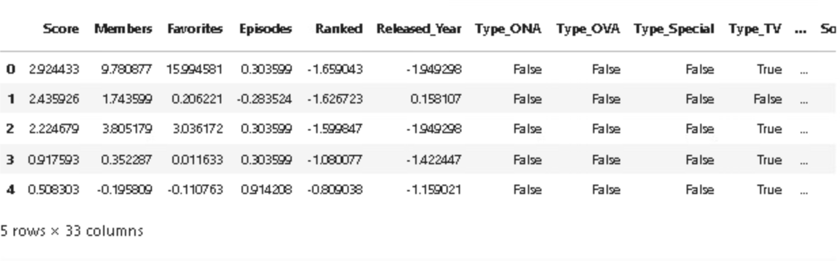

Summary of Findings
The dataset did have strong popularity indicators with skewedness. Score was stable overall and had a normal distribution which allowed for making it a more reliable target. Categorical features did show a meaningful separation in the pair plots. Missing data was concentrated in the non-essential fields. In preprocessing, conversion of all features into a numeric and model ready format was done successfully.

